
Koneru Lakshmaiah Education Foundation
(Deemed to be University estd. u/s. 3 of the UGC Act, 1956)
Off-Campus: Bachupally-Gandimaisamma Road, Bowrampet, Hyderabad, Telangana - 500 043. Phone No: 7815926816, www.klh.edu.in

STUDENT CASE STUDY EXECUTION REPORT
Department | FED
Subject | DSA-2
Academic Year | 1-III Semester (2025-2026)
Faculty Name | Mohd. Razia Alangir Banu
Student Name | M.Geethika
Roll Number | 2520030485
Branch | CSE
Course Outcome | Analyze and implement Dijkstra's, Bellman-Ford, and Floyd-Warshall shortest-path algorithms to compare their applicability and correctness across different graph types (weighted/unweighted, directed/undirected, negative-weight edges) in logistics and routing system case studies.

Case Study Topic: EduGraph – Adaptive Learning & Course Recommendation Platform
Work Done Summary:
Implemented Dijkstra's, Bellman-Ford, and Floyd-Warshall algorithms for shortest-path analysis. Compared their performance and applicability on different graph types. Handled weighted, directed, undirected, and negative-weight edge scenarios. Evaluated routing efficiency and correctness in logistics and transportation case studies.
Implementation Details:

- Implemented Dijkstra's algorithm to find the shortest path in graphs with non-negative edge weights.
- Applied Bellman-Ford algorithm to handle graphs containing negative-weight edges and detect negative cycles.
- Used Floyd-Warshall algorithm to compute shortest paths between all pairs of vertices.
- Compared algorithm performance across weighted, directed, and undirected graph structures.
- valuated routing efficiency, correctness, and applicability in logistics and transportation case studies.

Result: Screenshots / Output
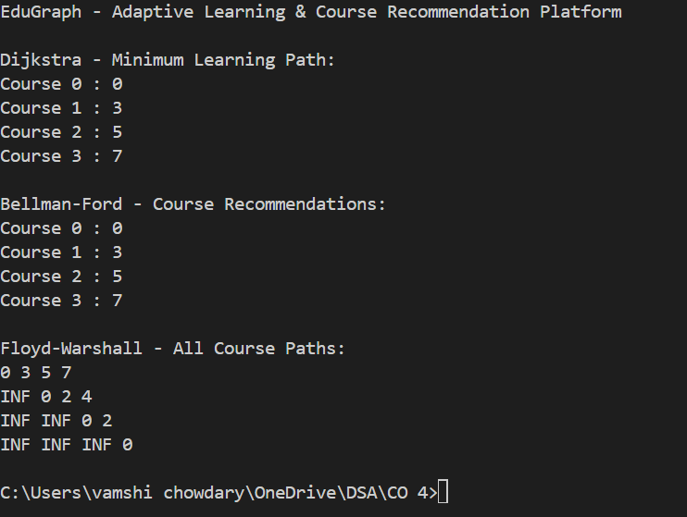

The program successfully implemented Dijkstra's, Bellman-Ford, and Floyd-Warshall algorithms for shortest-path computation. It correctly found optimal routes in different graph types. The algorithms were compared based on performance and applicability. The implementation improved route analysis in logistics and routing systems.
GitHub Link:
https://github.com/geethika04-dot/DSA-2
NOTE: The code and Screenshots and PDF have been uploaded in the above link, please check it there.

Student Signature: Faculty Signature:

